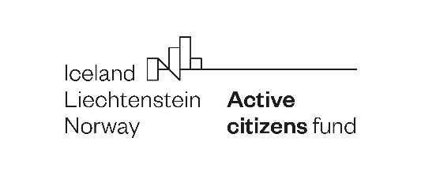
Active Citizens Days 2021
Active Citizens 4 Human Rights
An online and offline capacity building process

Target group: 50 representatives of small sized/ grass route/ local human rights NGOs, interested in capacity building from all the 15 beneficiary states (approx 40) and donor states (approx 10).

Goal: To give the opportunity to organizations from beneficiary countries and Norway to come together, learn and discuss issues that they have in their organizations and in their work, especially in relation to specific challenges for building capacity of local/ grass route human rights NGOs.

Objectives:
- To create a platform for learning and sharing experience about capacity building for local/ grass route human rights NGOs;
- To enhance cooperation and enable partnership between entities in Norway and beneficiary countries in relation to capacity building for human rights issues;

Outcomes:
- Raised awareness in dealing with capacity building issues;
- Raised awareness about different strategies applied by organizations in relation to capacity building;
- Raised cooperation among participating organizations for possible future partnerships.
Phases of the intervention

- Selection of organizations from beneficiary states and Norway
January-February 2021 - call for selection of organizations from beneficiary states (involvement also of POs) and invites to organisations in Norway

- Pre-event process - involvement of selected organisations in monthly meetings (1 meeting per month) on different topics. Format - zoom meetings with 1 to many presentations and work groups, approx 4 hours each meeting.
March 2021 - Connecting month - online facilitated meeting that puts together organisations involved in the process from Norway and beneficiary states and creates the context in which they can share important aspects related to their work, a meeting out of which we will extract ideas about their needs of capacity building. ”Homework” to be given for the next meeting.
April 2021 - Crisis management month - online meeting with Norwegian and beneficiary state organisations + expert(s) on the topic from NO or international = discussions and methodologies on how to deal with crisis situations, especially in the pandemic reality (with use of the homework as material for discussions). ”Homework” to be given for the next meeting.
May 2021 - Constituency month - online meeting with Norwegian and beneficiary state organisations + expert(s) on the topic from Norway or international = discussions and methodologies on how to create more followers/ engage people more into the work of the organisations (with use of the homework as material for discussions). ”Homework” to be given for the next meeting.
June 2021 - Campaigning month - online meeting with Norwegian and beneficiary state organisations + expert(s) on the topic from Norway or international = discussions and methodologies on how to effectively run human rights campaigns, especially at local level (with use of the homework as material for discussions). ”Homework” to be given for the next meeting.
July - August 2021 - Practice months = based on the meetings we have we give out some more “homeworks” for them to put into practice before the meeting

- Meeting in Oslo for all participants in September/October 2021.
More information on this meeting will come at a later stage.

Practical info on number of participants
The number of participants for each country is determined by the size of the ACF program. In case there is smaller interest from some countries and a higher interest from other countries, the number of places can be subject to redistribution/changes. We will keep you posted on this.

Poland + Romania = 7 in total - 3 and 4 places each

Bulgaria + Czech Republic + Greece + Portugal = 3 places each (12 in total)

Croatia + Estonia + Latvia + Lithuania + Slovakia = 3 places each (15 in total)

Malta + Slovenia + Cyprus = 2 places each (6 in total)

Norway = 10 places

